*a n*

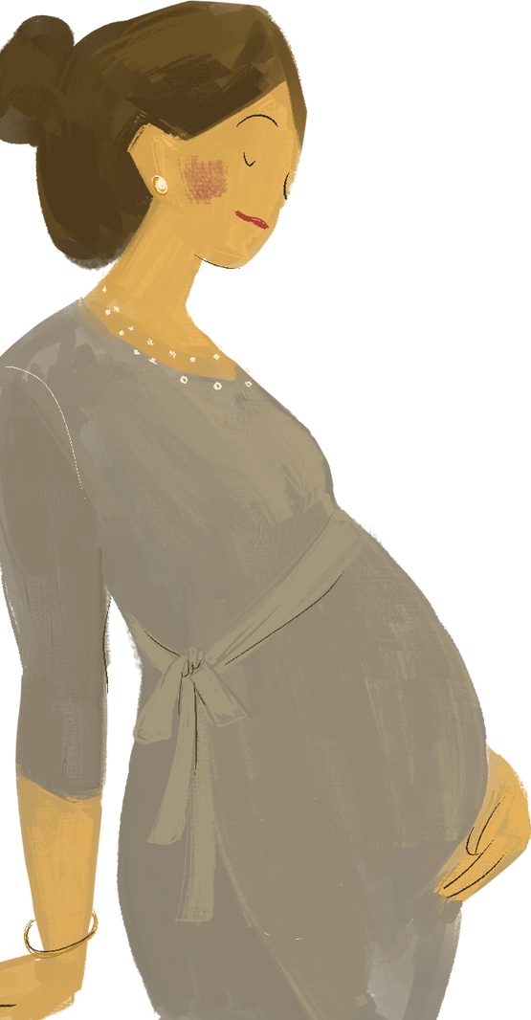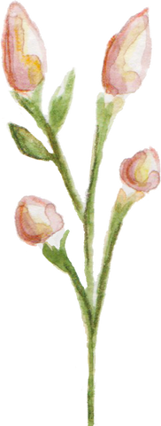

*c*

Submitted by:

Himanshi Parashar(2216284) Mansi Mishra(2216319) Manya Bhardwaj(2216321) Manya Jain(2216322) Radhika Goyal (2216360)

Class: B.Tech(CS) 3rd year VI sem Section: B

Group no.: 6

Submitted to: Aarti Ma’am



Pregnancy is generally a natural and healthy process, but it can sometimes come with complications that affect the mother, baby, or both. Early recognition and management are crucial to ensuring a safe pregnancy and delivery.



*a n*

*c*

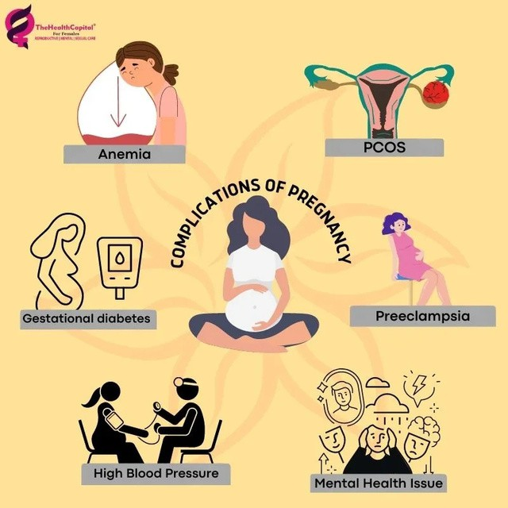





*Morning Sickness*

Morning sickness is nausea and vomiting that many pregnant women experience, usually in the first trimester. It can happen at any time of day, but it’s most common in the morning. It’s caused by changes in hormones during pregnancy.

Few home treatment remedies to deal with Morning Sickness are:

 Ginger: Ginger has natural anti-nausea properties. You can try ginger tea, ginger candies, or even fresh ginger slices to help ease symptoms.

 Stay Hydrated: Dehydration can worsen nausea. Sip small amounts of water, coconut water, or electrolyte drinks throughout the day to stay hydrated.

 Eat Small Meals: Eating small, bland meals like crackers, rice, or toast

can prevent an empty stomach, which often triggers nausea. Avoid heavy or greasy foods.

 Avoid Strong Odors: Strong smells from food, perfumes, or cleaning

products can worsen nausea. Try to avoid these triggers and get fresh air when needed.

 Vitamin B6: Vitamin B6 is often recommended for morning sickness.

Consider taking supplements (with your doctor’s approval) or eating foods like bananas, poultry, and potatoes.



 Peppermint: Peppermint can relax the stomach muscles.

Try peppermint tea, chewing gum, or even sniffing peppermint oil to ease nausea.

 Acupressure: Acupressure wristbands apply pressure to

specific points on your wrists, which may help reduce nausea. They are easy to use and drug-free.

 Rest: Being well-rested can help prevent fatigue from

making nausea worse. Take naps, avoid overexertion, and listen to your body’s need for rest.

 Fresh Air: Fresh air can help reduce nausea and refresh

your senses. Take a short walk outside or open windows for ventilation if you’re indoors.

 Lemon: The fresh scent of lemon can ease nausea for

some people. Try sucking on lemon wedges, drinking lemon water, or using lemon essential oils for relief.

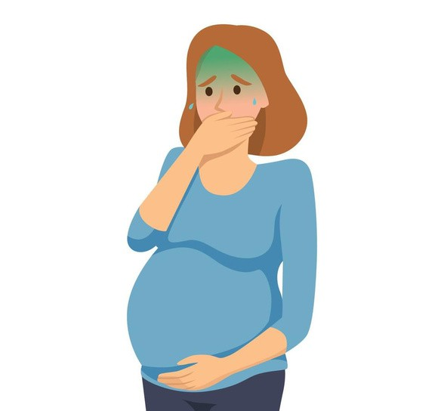





*Heartburn & Indigestion*

Heartburn is a burning feeling in your chest or throat caused by stomach acid moving up into your esophagus.

Indigestion is discomfort or pain in your stomach, often felt as bloating, gas, or a full feeling after eating. Both can be common during pregnancy.

Few home treatment remedies to deal with Heartburn & Indigestion are:

 Eat Smaller Meals: Eating 5-6 small meals instead of 3 large ones can help reduce stomach pressure. This may prevent acid reflux and indigestion.

 Avoid Trigger Foods: Steer clear of spicy, greasy, or acidic foods, which

can worsen heartburn. Pay attention to which foods trigger your symptoms.

 Elevate Your Head: Sleeping with your upper body elevated keeps

stomach acid from moving up into your esophagus. Use pillows or a wedge to prop yourself up.

 Drink Ginger Tea: Ginger can soothe your stomach and reduce acid

reflux. Sip ginger tea or chew a small piece of fresh ginger after meals.

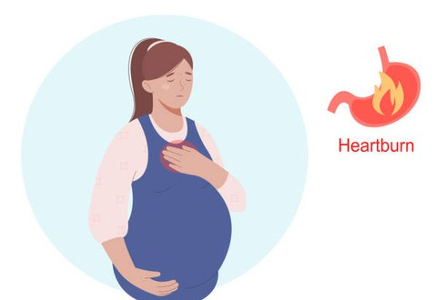 Stay Upright After Eating: Lying down too soon after eating can trigger heartburn. Stay upright for at least 30 minutes after meals to help with digestion.



 Chew Gum: Chewing sugar-free gum increases saliva production, which helps neutralize stomach acid. This can ease heartburn and indigestion.



 Drink Water: Water helps dilute stomach acid, which can

reduce discomfort from heartburn. Drink water throughout the day, especially between meals.

 Wear Loose Clothing: Tight clothes can put pressure on

your stomach, making heartburn worse. Opt for loose, comfortable clothing to prevent this.

 Apple Cider Vinegar: A small amount of diluted apple

cider vinegar can help with digestion. Mix 1-2 teaspoons in water and drink it before meals.

 Baking Soda: Baking soda neutralizes stomach acid

temporarily. Mix 1/2 teaspoon with water and drink it to relieve heartburn symptoms.

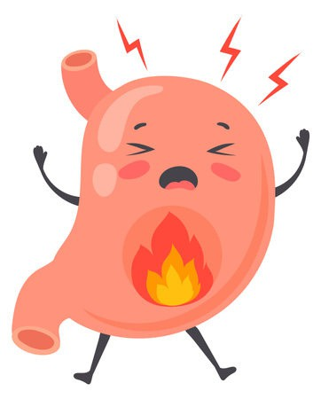





*Leg Cramps*

Leg cramps are a common issue during pregnancy, especially in the second and third trimesters. They often occur at night and can be uncomfortable or even painful.

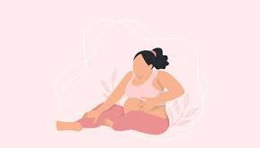Here are some home treatment to deal with Leg Cramps.

 Stretching Exercises:

Before bed, gently stretch your calf muscles. Stand facing a wall, place your hands on it, and step one leg back. Keep the back leg straight and bend the front leg slightly, stretching the calf.

 Stay Hydrated: Drink plenty of water throughout the day. Add lemon or a pinch of salt for electrolytes if needed.

Warm Compress or Bath: Use a warm compress on the cramping area or soak in a warm bath with Epsom salts to relax muscles.

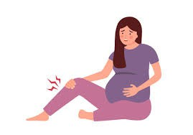

 Warm Compress or Bath: Use a warm compress on the cramping area or soak in a warm bath with Epsom salts to relax muscles.

 Massage: Gently massage the affected leg when cramps occur. Use circular motions to improve blood flow.

 Elevate Your Legs: Avoid prolonged standing or sitting. Elevate your legs while resting to improve circulation.

 Footwear: Wear comfortable shoes with proper arch support to reduce strain on leg muscles.

 Magnesium-Rich Foods: Include magnesium-rich foods in your diet, such as nuts, seeds, whole grains, spinach, and bananas.

 Calcium and Potassium: Consume calcium-rich foods like milk, cheese, and yogurt. Potassium-rich options include bananas, oranges, and avocados.

 Sleep Position: Sleep on your left side to improve blood flow and reduce pressure on your veins.



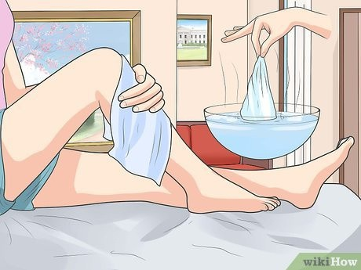



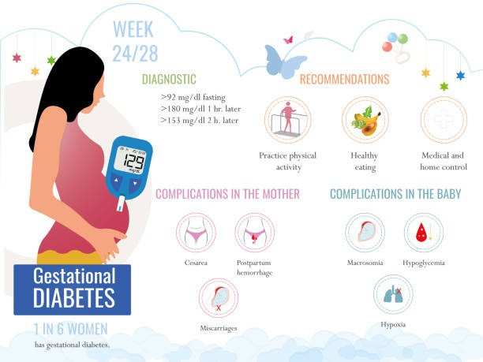

*Gestational Diabetes*

Gestational Diabetes (GD) occurs during pregnancy when the body cannot effectively use insulin, leading to higher blood sugar levels. It typically develops in the second or third trimester and often resolves after delivery. However, managing blood sugar levels during pregnancy is crucial to avoid complications for both mother and baby.

Here are some home treatment to deal with Gestational Diabetes:

 Balanced Diet:

-Eat Low-Glycemic Foods: Focus on foods that release sugar slowly, such as whole grains, legumes, and non-starchy vegetables.

-High-Fiber Foods: Include foods like oats, lentils, broccoli, and chia seeds to improve blood sugar control.

-Controlled Carbohydrate Intake: Avoid simple sugars and refined carbs (white bread, sweets, sugary drinks).

 Stay Hydrated:

Avoid sugary drinks and juices. Drink plenty of water throughout the day to regulate blood sugar levels.

 Regular Exercise:

-Engage in moderate physical activities, such as:

Walking after meals Prenatal yoga Swimming

-Exercise helps improve insulin sensitivity and maintain healthy weight gain.

 Herbal and Natural Remedies:

-Cinnamon: May help regulate blood sugar levels. Add a small amount to meals or teas.

-Fenugreek Seeds: Known for their blood sugar-lowering effects, they can be soaked overnight and consumed in the morning.



-Bitter Gourd: Drinking bitter gourd juice in moderation can help manage glucose levels.

-Amla (Indian Gooseberry): Rich in Vitamin C, it may help control blood sugar levels when consumed as juice or fresh fruit.

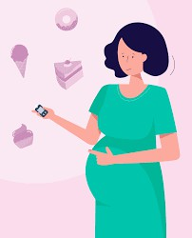 Stress Management:

-High stress can affect blood sugar levels.

Deep breathing exercises Meditation

Gentle stretching or relaxation techniques

 Monitor Blood Sugar Levels:

-Regularly check your blood sugar levels with a glucometer to track changes and take timely action.

 Avoid High-Sugar Foods:

-Replace sugar with natural sweeteners like stevia in moderation.

-Limit candies, baked goods, sugary drinks, and desserts.

 Lifestyle Changes:

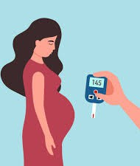

-Walking Barefoot on Grass

-Frequent Small Meals

-Sleep Well

 Natural Supplements:

-Guava

-Jamun (Indian Blackberry)

-Curry Leaves

 Hydration:

-Herbal Teas

-Coconut Water





*Preterm Labor*

Preterm labor happens when a pregnant person starts having contractions and their cervix begins to open too early, before 37 weeks of pregnancy.

Normally, babies are born around 40 weeks, so when labor starts too soon, the baby might be born early, which can cause health risks for both the baby and the parent. Preterm labor can happen for many reasons, but it’s important to get medical help right away if it happens.

Few home treatment remedies to deal with Preterm Labor are:

 Rest and Relax: Lying on your left side and getting plenty of rest helps reduce pressure on your uterus and improves blood flow, which may reduce contractions.

 Stay Hydrated: Dehydration can cause contractions. Drinking water

regularly may help prevent or reduce them.

 Avoid Stress: Stress can trigger contractions, so practicing relaxation techniques like meditation or deep breathing can help keep you calm.

 Monitor Contractions: Keep track of how often contractions are happening. If they become regular or painful, contact your doctor immediately.

 Reduce Physical Activity: Avoid heavy lifting and strenuous exercises

that can strain your body. Take breaks and prioritize light activities.





 Eat Balanced, Small Meals: Eating smaller, more frequent meals can help avoid discomfort or bloating that may trigger contractions.

 Warm Bath: Soaking in a warm bath (not hot) can help

relax your muscles and ease any tension that may be causing contractions.

 Maintain Good Posture: Sitting or standing with proper

posture helps reduce pressure on your uterus, which can help prevent contractions.

 Avoid Infection: Pay attention to any signs of infection,

like burning when urinating or unusual discharge. Infections can sometimes lead to preterm labor.

 Stay Comfortable and Avoid Overheating: Being too hot

or uncomfortable can stress your body. Make sure you're in a cool, comfortable environment and wear loose, breathable clothing to help you relax.

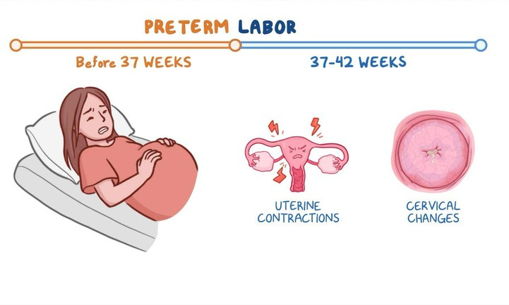





*Miscarriage*

A miscarriage is when a pregnancy ends on its own before the baby can live outside the womb, usually before 20 weeks. This means the baby stops growing, and the person who’s pregnant might have bleeding or cramping. It can happen for many reasons, often beyond anyone's control, like problems with the baby’s development or health issues with the pregnant person.

Few home treatment remedies to deal with Miscarriage are:

 Rest: Getting plenty of rest after a miscarriage helps your body recover. Lying down or resting in a comfortable position may help ease physical discomfort.

 Stay Hydrated: Drinking lots of water is important to prevent

dehydration, especially if you've had bleeding. Hydration supports the healing process.

 Gentle Exercise: Light walking or stretching (once cleared by a doctor)

can help your body feel better and ease tension, but avoid heavy physical activity.

 Use a Heating Pad: A heating pad or warm compress can help soothe

cramping or discomfort. Be careful not to make it too hot to avoid further irritation.

 Eat Nutritious Foods: Focus on a healthy diet with fruits, vegetables, and

lean proteins to support your body’s recovery. Proper nutrition aids in healing.

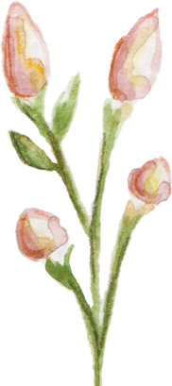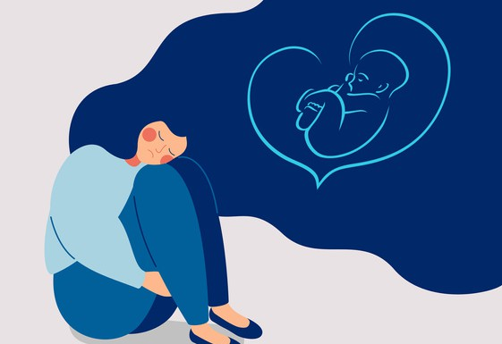

 Avoid Stress: Emotional well-being is key after a miscarriage. Try to engage in calming activities like reading, meditating, or listening to soothing music.

 Seek Emotional Support: Surround yourself with people

who care and talk about your feelings. Emotional healing is just as important as physical healing.

 Take Iron Supplements: If you’ve experienced heavy

bleeding, your doctor may suggest iron supplements to help replenish lost iron and prevent anemia.

 Maintain a Comfortable Environment: Creating a

relaxing, peaceful space to rest can promote mental and emotional recovery. Soft lighting, cozy blankets, and calming scents may help.

 Follow Up with Your Doctor: After a miscarriage, it's

essential to follow up with your doctor to ensure that everything is healing properly. They can also provide advice on when it’s safe to try for another pregnancy or if further care is needed.

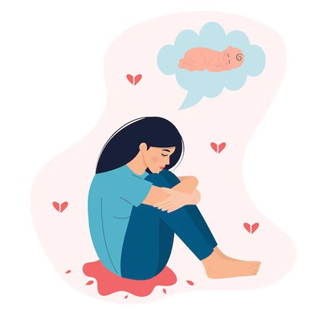





*Hemorrttoids*

Hemorrhoids during pregnancy are swollen and inflamed veins in the rectal or anal area, caused by increased pressure from the growing uterus, hormonal changes that relax vein walls, and the added strain of constipation, which is common in pregnancy.

Few home treatment remedies to deal with Miscarriage are:

 High-Fiber Diet: Eat plenty of fiber-rich foods, such as fruits, vegetables, whole grains, and legumes, to soften stools and prevent constipation.

 Hydration: Drink 8-10 glasses of water daily to support healthy digestion and prevent hard stools.

 Warm Sitz Baths: Soak the affected area in warm water for 10-15 minutes, two to three times a day, to reduce swelling and relieve pain.

 Cold Compresses: Apply a cold pack or wrapped ice to the area for 10 minutes to reduce inflammation and provide immediate relief.

 Witch Hazel Pads: Use cotton pads soaked in witch hazel to soothe irritation and reduce swelling.



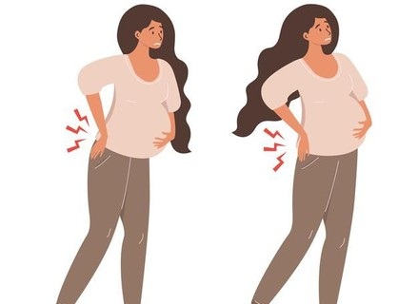

 Kegel Exercises: Strengthen pelvic muscles to improve blood flow and reduce rectal pressure.

 Proper Toilet Habits: Avoid straining during bowel movements.

Elevating your feet on a small stool can help with easier passage of stools.

 Avoid Prolonged Sitting: Limit time sitting on hard surfaces to reduce pressure on the rectal veins. Use a cushioned seat or donut pillow for added comfort.

 Frequent Movement: Engage in light physical activities or take short walks to improve circulation and prevent blood pooling in the veins.

 Gentle Cleaning: Use soft, unscented wipes or damp toilet paper to clean the area gently after bowel movements, avoiding irritation from rough materials.

 Safe Topical Treatments: Consult your healthcare provider about pregnancy-safe creams or ointments that can reduce itching and swelling.

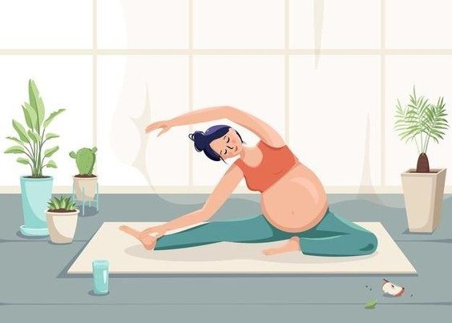





*Hypertension*

Hypertension, or high blood pressure during pregnancy, is a condition where the force of blood against the walls of the arteries is consistently elevated, often caused by increased blood volume, hormonal changes, or preexisting conditions. Proper management is crucial to avoid complications such as preeclampsia.

Few home treatment remedies to deal with Miscarriage are:

 Low-Sodium Diet: Limit salt intake by avoiding processed and packaged foods. Opt for fresh, home-cooked meals.

 Balanced Diet: Include potassium-rich foods like bananas, spinach, avocados, and sweet potatoes to help regulate blood pressure naturally. Ensure adequate intake of lean proteins, whole grains, and healthy fats.

 Stay Hydrated: Drink at least 8-10 glasses of water daily to support circulation and kidney function.

 Gentle Exercise: Engage in safe, low-impact activities like walking, swimming, or prenatal yoga after consulting your doctor.

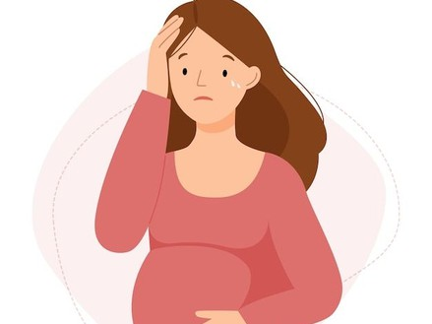

 Stress Management: Practice relaxation techniques like deep breathing, mindfulness meditation, or prenatal massages to reduce stress levels.

 Adequate Rest: Rest on your left side to improve blood flow to the placenta and reduce pressure on major blood vessels.

 Herbal Teas: Sip on pregnancy-safe herbal teas, such as chamomile or hibiscus, to promote relaxation, but consult your doctor first for safety.

 Magnesium Intake: Include magnesium-rich foods like nuts, seeds, and leafy greens in your diet to help relax blood vessels and lower blood pressure.

 Maintain a Healthy Weight: work with your healthcare provider to ensure you maintain a healthy weight during pregnancy, as excessive weight gain can contribute to hypertension.

 Monitor Blood Pressure: Regularly check your blood pressure using a reliable home device and track readings.

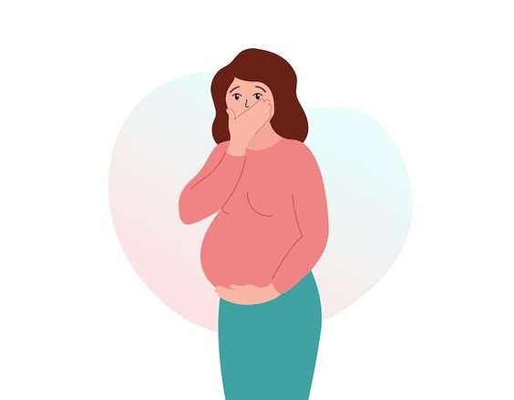





*Varicose veins*

Varicose veins are swollen, twisted veins that usually occur in the legs due to weak or damaged vein walls and valves, which cause blood to pool. They often appear blue or purple and may cause pain, swelling, heaviness, or itching. Factors like age, genetics, obesity, and prolonged standing or sitting can increase the risk.

Few home treatment remedies to deal with Varicose veins are:

Exercise:

-Boosts circulation and strengthens leg muscles.

-Prevents blood pooling in veins and reduces pressure.

-Activities like swimming or cycling are also low-impact and highly beneficial.

Elevate Your Legs:

-Keeps legs above heart level to use gravity for blood flow.

-Reduces swelling and discomfort effectively.

-Helps relieve pressure in veins after long periods of standing or sitting.

Compression Stockings:



-Apply gentle pressure to improve blood flow.

-Prevents vein enlargement and relieves pain.

-Ideal for daily use, especially during travel or prolonged sitting/standing.

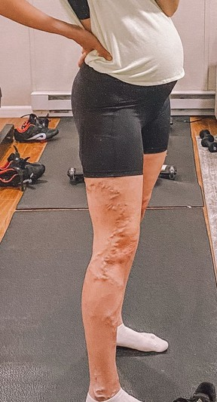Apple Cider Vinegar (ACV):

-Improves circulation and reduces inflammation when applied topically.

-Drinking diluted ACV supports blood flow internally.

-Regular use may help reduce the appearance of varicose veins over time.

Massage:

-Gentle upward strokes improve circulation and relieve discomfort.

-Use natural oils like coconut or olive for added benefits.

-Add essential oils like lavender or peppermint for extra soothing effects.

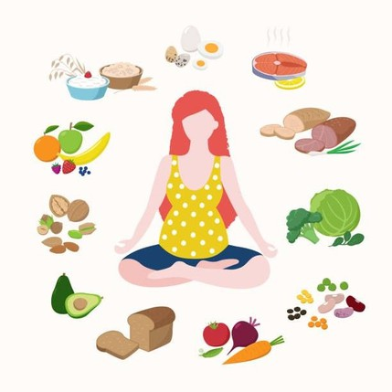Dietary Changes:

-High-fiber foods prevent constipation, reducing vein pressure.

-Low-salt diet reduces water retention and swelling.

-Include potassium-rich foods like bananas and sweet potatoes to reduce vein strain.







*Frequent Urination*

Frequent urination refers to the need to urinate more often than usual, which may interrupt daily life or sleep. It can result from various causes, including urinary tract infections (UTIs), diabetes, pregnancy, anxiety, or excess fluid intake. While generally harmless, it can sometimes signal an underlying health condition, especially if accompanied by other symptoms like pain or discomfort.

Few home treatment remedies to deal with Frequent Urination are:

Limit Caffeine and Alcohol:

 Both act as diuretics, increasing urine production and frequency.

 Reducing intake helps lessen bladder irritation.

 Opt for water, herbal teas, or decaffeinated beverages instead.

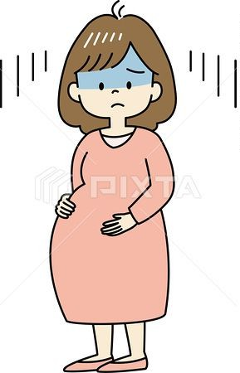

Bladder Training:

 Gradually increase the time between bathroom visits to retrain your bladder.

 Start by delaying urination for 5-10 minutes when you feel the urge.

 Over time, this can help improve bladder capacity and control.



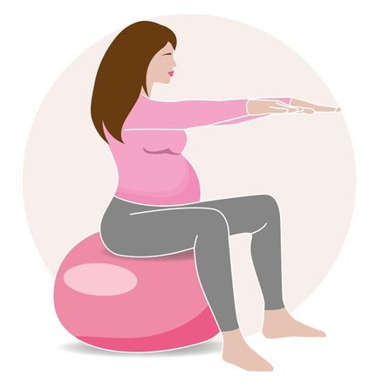Pelvic Floor Exercises (Kegels):

-Strengthen the muscles controlling urination, improving bladder control.

- Perform by contracting and holding the pelvic floor muscles for 5-10 seconds.

-Do 3 sets of 10-15 repetitions

daily for best results.

Avoid Bladder Irritants:

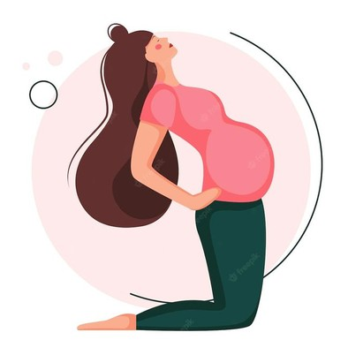

 Limit spicy foods, acidic citrus fruits, and artificial sweeteners, which can irritate the bladder.

 Monitor your diet to identify triggers that worsen frequent urination.

 Replace irritants with soothing options like oatmeal or non-citrus fruits

Cranberry Juice:

 Helps prevent and manage urinary tract infections (UTIs), a common cause of frequent urination.

 Contains compounds that stop bacteria from adhering to the bladder walls.

 Choose unsweetened cranberry juice for the best results.

Pumpkin Seeds:

 Rich in omega-3 fatty acids, which support bladder health and reduce urinary urgency.

 Consume a handful daily as a snack or add them to meals.  Pumpkin seed extract supplements are also an option

Stay Hydrated (Moderately):

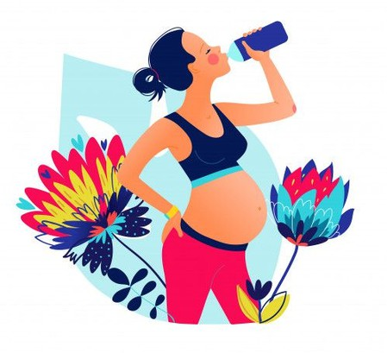

 Drink enough water to keep urine light-colored, but avoid overhydration.

 Too much water can strain the bladder and increase urgency.

 Spread your fluid intake evenly throughout the day.





# A

you